## **Visualize Away!**

**Klar til at fuldføre**

For this Visualisation assignment, you engage in two tasks and submit an rmarkdown document with a knitted result that collects the results of both tasks:

**A:** **same for everyone:** Visualize the duration of reign among Danish kings **through time** (showing the diachronic trend from ca 900 - today on the x axis) with **ggplot**. Use the dataset you/your group has created and submit both the script and the visualisation, ideally as part of an rmarkdown and html document (for details see bottom of this page). Experiment with geom_point(), geom_line() or geom_smooth() functions for the geometry.

ggplot og tidyverse “tændes” 



Først indlæses excelarket med kongerækken:



Herefter dannes x-aksen



Herefter dannes et diagram i R



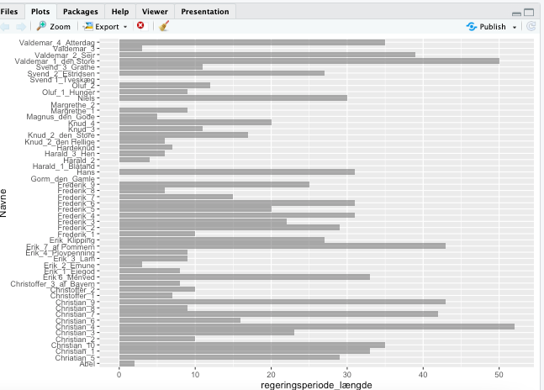

**B:** choose **one** of the two options below and follow the instructions in rmarkdowns. These have slightly different content depending on what you wish to practice, whether facets in ggplot or animation. For the latter, pay attention to the prerequisites R specifies for your system:

1) Historical homicide trends across Western Europe (ggplot practice)<https://github.com/Digital-Methods-HASS/HomicideHistory>

Link til github: https://github.com/Digital-Methods-HASS/AU611515_Lindegaard_Morten/blob/main/EuropeanHomicide_exercise.Rmd